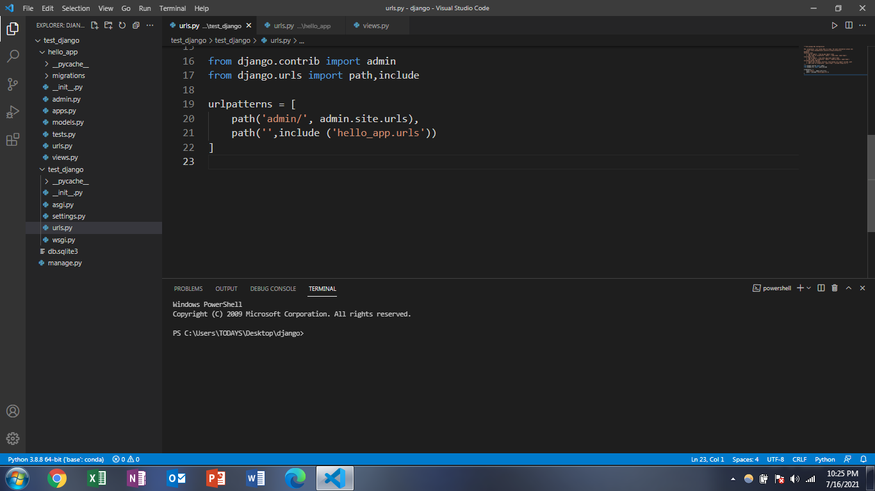

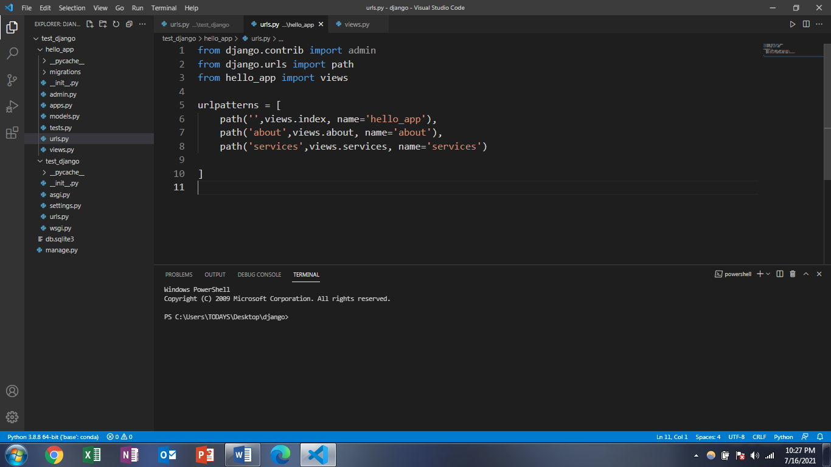

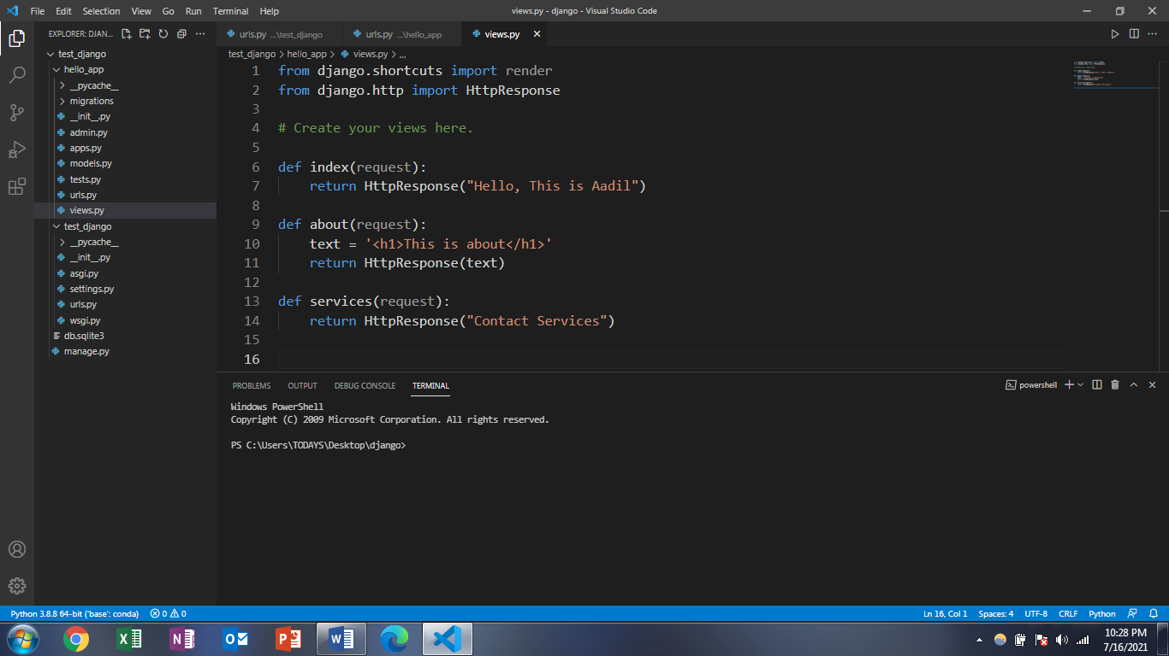

STEPS:-

WHEN WE TOUCH THE WEBSERVER PORT Eg:- 8000

IT FIRST GOES TO THE PROJECTS URL AND IF THE NAME IS ADMIN IT SHOWS DJANGO ADMIN PAGE,

BUT IF THE NAME IS BLANK IT GOES TO APP’S URL AND THEN IT GOES TO THE VIEW PAGE RENDER.

HTTPRESPONSE IS ADDED FOR DISPLAYING THE STRINGS

Code with harry

POWER-SHELL COMMANDS HISTORY

Windows PowerShell

Copyright (C) 2009 Microsoft Corporation. All rights reserved.

PS C:\Users\TODAYS\Desktop\django> django-admin startproject Hello_app

PS C:\Users\TODAYS\Desktop\django> django-admin startproject test_django

PS C:\Users\TODAYS\Desktop\django> python manage.py runserver

C:\Users\TODAYS\AppData\Local\Programs\Python\Python37\python.exe: can't open file 'manage.py': [Errno 2] No such file or directory

PS C:\Users\TODAYS\Desktop\django> python manage.py runserver

C:\Users\TODAYS\AppData\Local\Programs\Python\Python37\python.exe: can't open file 'manage.py': [Errno 2] No such file or directory

PS C:\Users\TODAYS\Desktop\django> cd test_django

PS C:\Users\TODAYS\Desktop\django\test_django> python manage.py runserver

Watching for file changes with StatReloader

Performing system checks...

System check identified no issues (0 silenced).

You have 18 unapplied migration(s). Your project may not work properly until you apply the migrations for app(s): admin, auth, contenttypes, sessions.

Run 'python manage.py migrate' to apply them.

July 16, 2021 - 18:16:34

Django version 3.2.5, using settings 'test_django.settings'

Starting development server at http://127.0.0.1:8000/

Quit the server with CTRL-BREAK.

[16/Jul/2021 18:16:47] "GET / HTTP/1.1" 200 10697

Not Found: /favicon.ico

[16/Jul/2021 18:16:49] "GET /favicon.ico HTTP/1.1" 404 2115

[16/Jul/2021 18:23:25] "GET /admin HTTP/1.1" 301 0

[16/Jul/2021 18:23:25] "GET /admin/ HTTP/1.1" 302 0

[16/Jul/2021 18:23:25] "GET /admin/login/?next=/admin/ HTTP/1.1" 200 2214

[16/Jul/2021 18:23:26] "GET /static/admin/css/login.css HTTP/1.1" 200 939

[16/Jul/2021 18:23:26] "GET /static/admin/css/nav_sidebar.css HTTP/1.1" 200 2271

[16/Jul/2021 18:23:26] "GET /static/admin/css/base.css HTTP/1.1" 200 19513

[16/Jul/2021 18:23:26] "GET /static/admin/js/nav_sidebar.js HTTP/1.1" 200 1360

[16/Jul/2021 18:23:26] "GET /static/admin/css/responsive.css HTTP/1.1" 200 18545

Windows PowerShell

Copyright (C) 2009 Microsoft Corporation. All rights reserved.

PS C:\Users\TODAYS\Desktop\django> conda activate base

The term 'conda' is not recognized as the name of a cmdlet, function, script file, or operable program. Check the spelling of the name, or if a path was included,

verify that the path is correct and try again.

At line:1 char:6

+ conda <<<< activate base

+ CategoryInfo : ObjectNotFound: (conda:String) [], CommandNotFoundException

+ FullyQualifiedErrorId : CommandNotFoundException

PS C:\Users\TODAYS\Desktop\django> cd test_django

PS C:\Users\TODAYS\Desktop\django\test_django> python manage.py runserver

Watching for file changes with StatReloader

Performing system checks...

Exception in thread django-main-thread:

Traceback (most recent call last):

File "C:\Users\TODAYS\AppData\Local\Programs\Python\Python37\lib\threading.py", line 926, in _bootstrap_inner

self.run()

File "C:\Users\TODAYS\AppData\Local\Programs\Python\Python37\lib\threading.py", line 870, in run

self._target(*self._args, **self._kwargs)

File "C:\Users\TODAYS\AppData\Local\Programs\Python\Python37\lib\site-packages\django\utils\autoreload.py", line 64, in wrapper

fn(*args, **kwargs)

File "C:\Users\TODAYS\AppData\Local\Programs\Python\Python37\lib\site-packages\django\core\management\commands\runserver.py", line 118, in inner_run

self.check(display_num_errors=True)

File "C:\Users\TODAYS\AppData\Local\Programs\Python\Python37\lib\site-packages\django\core\management\base.py", line 423, in check

databases=databases,

File "C:\Users\TODAYS\AppData\Local\Programs\Python\Python37\lib\site-packages\django\core\checks\registry.py", line 76, in run_checks

new_errors = check(app_configs=app_configs, databases=databases)

File "C:\Users\TODAYS\AppData\Local\Programs\Python\Python37\lib\site-packages\django\core\checks\urls.py", line 13, in check_url_config

return check_resolver(resolver)

File "C:\Users\TODAYS\AppData\Local\Programs\Python\Python37\lib\site-packages\django\core\checks\urls.py", line 23, in check_resolver

return check_method()

File "C:\Users\TODAYS\AppData\Local\Programs\Python\Python37\lib\site-packages\django\urls\resolvers.py", line 412, in check

for pattern in self.url_patterns:

File "C:\Users\TODAYS\AppData\Local\Programs\Python\Python37\lib\site-packages\django\utils\functional.py", line 48, in __get__

res = instance.__dict__[self.name] = self.func(instance)

File "C:\Users\TODAYS\AppData\Local\Programs\Python\Python37\lib\site-packages\django\urls\resolvers.py", line 598, in url_patterns

patterns = getattr(self.urlconf_module, "urlpatterns", self.urlconf_module)

File "C:\Users\TODAYS\AppData\Local\Programs\Python\Python37\lib\site-packages\django\utils\functional.py", line 48, in __get__

res = instance.__dict__[self.name] = self.func(instance)

File "C:\Users\TODAYS\AppData\Local\Programs\Python\Python37\lib\site-packages\django\urls\resolvers.py", line 591, in urlconf_module

return import_module(self.urlconf_name)

File "C:\Users\TODAYS\AppData\Local\Programs\Python\Python37\lib\importlib\__init__.py", line 127, in import_module

return _bootstrap._gcd_import(name[level:], package, level)

File "<frozen importlib._bootstrap>", line 1006, in _gcd_import

File "<frozen importlib._bootstrap>", line 983, in _find_and_load

File "<frozen importlib._bootstrap>", line 967, in _find_and_load_unlocked

File "<frozen importlib._bootstrap>", line 677, in _load_unlocked

File "<frozen importlib._bootstrap_external>", line 728, in exec_module

File "<frozen importlib._bootstrap>", line 219, in _call_with_frames_removed

File "C:\Users\TODAYS\Desktop\django\test_django\test_django\urls.py", line 21, in <module>

path('',include ('hello_app.urls'))

File "C:\Users\TODAYS\AppData\Local\Programs\Python\Python37\lib\site-packages\django\urls\conf.py", line 34, in include

urlconf_module = import_module(urlconf_module)

File "C:\Users\TODAYS\AppData\Local\Programs\Python\Python37\lib\importlib\__init__.py", line 127, in import_module

return _bootstrap._gcd_import(name[level:], package, level)

File "<frozen importlib._bootstrap>", line 1006, in _gcd_import

File "<frozen importlib._bootstrap>", line 983, in _find_and_load

File "<frozen importlib._bootstrap>", line 967, in _find_and_load_unlocked

File "<frozen importlib._bootstrap>", line 677, in _load_unlocked

File "<frozen importlib._bootstrap_external>", line 724, in exec_module

File "<frozen importlib._bootstrap_external>", line 860, in get_code

File "<frozen importlib._bootstrap_external>", line 791, in source_to_code

File "<frozen importlib._bootstrap>", line 219, in _call_with_frames_removed

File "C:\Users\TODAYS\Desktop\django\test_django\hello_app\urls.py", line 2

from django.urls import path,

^

SyntaxError: trailing comma not allowed without surrounding parentheses

C:\Users\TODAYS\Desktop\django\test_django\hello_app\urls.py changed, reloading.

Watching for file changes with StatReloader

Performing system checks...

System check identified no issues (0 silenced).

You have 18 unapplied migration(s). Your project may not work properly until you apply the migrations for app(s): admin, auth, contenttypes, sessions.

Run 'python manage.py migrate' to apply them.

July 16, 2021 - 18:43:36

Django version 3.2.5, using settings 'test_django.settings'

Starting development server at http://127.0.0.1:8000/

Quit the server with CTRL-BREAK.

C:\Users\TODAYS\Desktop\django\test_django\hello_app\views.py changed, reloading.

Watching for file changes with StatReloader

Performing system checks...

Exception in thread django-main-thread:

Traceback (most recent call last):

File "C:\Users\TODAYS\AppData\Local\Programs\Python\Python37\lib\threading.py", line 926, in _bootstrap_inner

self.run()

File "C:\Users\TODAYS\AppData\Local\Programs\Python\Python37\lib\threading.py", line 870, in run

self._target(*self._args, **self._kwargs)

File "C:\Users\TODAYS\AppData\Local\Programs\Python\Python37\lib\site-packages\django\utils\autoreload.py", line 64, in wrapper

fn(*args, **kwargs)

File "C:\Users\TODAYS\AppData\Local\Programs\Python\Python37\lib\site-packages\django\core\management\commands\runserver.py", line 118, in inner_run

self.check(display_num_errors=True)

File "C:\Users\TODAYS\AppData\Local\Programs\Python\Python37\lib\site-packages\django\core\management\base.py", line 423, in check

databases=databases,

File "C:\Users\TODAYS\AppData\Local\Programs\Python\Python37\lib\site-packages\django\core\checks\registry.py", line 76, in run_checks

new_errors = check(app_configs=app_configs, databases=databases)

File "C:\Users\TODAYS\AppData\Local\Programs\Python\Python37\lib\site-packages\django\core\checks\urls.py", line 13, in check_url_config

return check_resolver(resolver)

File "C:\Users\TODAYS\AppData\Local\Programs\Python\Python37\lib\site-packages\django\core\checks\urls.py", line 23, in check_resolver

return check_method()

File "C:\Users\TODAYS\AppData\Local\Programs\Python\Python37\lib\site-packages\django\urls\resolvers.py", line 412, in check

for pattern in self.url_patterns:

File "C:\Users\TODAYS\AppData\Local\Programs\Python\Python37\lib\site-packages\django\utils\functional.py", line 48, in __get__

res = instance.__dict__[self.name] = self.func(instance)

File "C:\Users\TODAYS\AppData\Local\Programs\Python\Python37\lib\site-packages\django\urls\resolvers.py", line 598, in url_patterns

patterns = getattr(self.urlconf_module, "urlpatterns", self.urlconf_module)

File "C:\Users\TODAYS\AppData\Local\Programs\Python\Python37\lib\site-packages\django\utils\functional.py", line 48, in __get__

res = instance.__dict__[self.name] = self.func(instance)

File "C:\Users\TODAYS\AppData\Local\Programs\Python\Python37\lib\site-packages\django\urls\resolvers.py", line 591, in urlconf_module

return import_module(self.urlconf_name)

File "C:\Users\TODAYS\AppData\Local\Programs\Python\Python37\lib\importlib\__init__.py", line 127, in import_module

return _bootstrap._gcd_import(name[level:], package, level)

File "<frozen importlib._bootstrap>", line 1006, in _gcd_import

File "<frozen importlib._bootstrap>", line 983, in _find_and_load

File "<frozen importlib._bootstrap>", line 967, in _find_and_load_unlocked

File "<frozen importlib._bootstrap>", line 677, in _load_unlocked

File "<frozen importlib._bootstrap_external>", line 728, in exec_module

File "<frozen importlib._bootstrap>", line 219, in _call_with_frames_removed

File "C:\Users\TODAYS\Desktop\django\test_django\test_django\urls.py", line 21, in <module>

path('',include ('hello_app.urls'))

File "C:\Users\TODAYS\AppData\Local\Programs\Python\Python37\lib\site-packages\django\urls\conf.py", line 34, in include

urlconf_module = import_module(urlconf_module)

File "C:\Users\TODAYS\AppData\Local\Programs\Python\Python37\lib\importlib\__init__.py", line 127, in import_module

return _bootstrap._gcd_import(name[level:], package, level)

File "<frozen importlib._bootstrap>", line 1006, in _gcd_import

File "<frozen importlib._bootstrap>", line 983, in _find_and_load

File "<frozen importlib._bootstrap>", line 967, in _find_and_load_unlocked

File "<frozen importlib._bootstrap>", line 677, in _load_unlocked

File "<frozen importlib._bootstrap_external>", line 728, in exec_module

File "<frozen importlib._bootstrap>", line 219, in _call_with_frames_removed

File "C:\Users\TODAYS\Desktop\django\test_django\hello_app\urls.py", line 3, in <module>

from hello_app import views

File "C:\Users\TODAYS\Desktop\django\test_django\hello_app\views.py", line 1

from django.shortcuts import render,

^

SyntaxError: trailing comma not allowed without surrounding parentheses

C:\Users\TODAYS\Desktop\django\test_django\hello_app\views.py changed, reloading.

Watching for file changes with StatReloader

Performing system checks...

System check identified no issues (0 silenced).

You have 18 unapplied migration(s). Your project may not work properly until you apply the migrations for app(s): admin, auth, contenttypes, sessions.

Run 'python manage.py migrate' to apply them.

July 16, 2021 - 18:52:38

Django version 3.2.5, using settings 'test_django.settings'

Starting development server at http://127.0.0.1:8000/

Quit the server with CTRL-BREAK.

C:\Users\TODAYS\Desktop\django\test_django\hello_app\views.py changed, reloading.

Watching for file changes with StatReloader

Performing system checks...

System check identified no issues (0 silenced).

You have 18 unapplied migration(s). Your project may not work properly until you apply the migrations for app(s): admin, auth, contenttypes, sessions.

Run 'python manage.py migrate' to apply them.

July 16, 2021 - 18:53:09

Django version 3.2.5, using settings 'test_django.settings'

Starting development server at http://127.0.0.1:8000/

Quit the server with CTRL-BREAK.

C:\Users\TODAYS\Desktop\django\test_django\hello_app\urls.py changed, reloading.

Watching for file changes with StatReloader

Performing system checks...

Exception in thread django-main-thread:

Traceback (most recent call last):

File "C:\Users\TODAYS\AppData\Local\Programs\Python\Python37\lib\threading.py", line 926, in _bootstrap_inner

self.run()

File "C:\Users\TODAYS\AppData\Local\Programs\Python\Python37\lib\threading.py", line 870, in run

self._target(*self._args, **self._kwargs)

File "C:\Users\TODAYS\AppData\Local\Programs\Python\Python37\lib\site-packages\django\utils\autoreload.py", line 64, in wrapper

fn(*args, **kwargs)

File "C:\Users\TODAYS\AppData\Local\Programs\Python\Python37\lib\site-packages\django\core\management\commands\runserver.py", line 118, in inner_run

self.check(display_num_errors=True)

File "C:\Users\TODAYS\AppData\Local\Programs\Python\Python37\lib\site-packages\django\core\management\base.py", line 423, in check

databases=databases,

File "C:\Users\TODAYS\AppData\Local\Programs\Python\Python37\lib\site-packages\django\core\checks\registry.py", line 76, in run_checks

new_errors = check(app_configs=app_configs, databases=databases)

File "C:\Users\TODAYS\AppData\Local\Programs\Python\Python37\lib\site-packages\django\core\checks\urls.py", line 13, in check_url_config

return check_resolver(resolver)

File "C:\Users\TODAYS\AppData\Local\Programs\Python\Python37\lib\site-packages\django\core\checks\urls.py", line 23, in check_resolver

return check_method()

File "C:\Users\TODAYS\AppData\Local\Programs\Python\Python37\lib\site-packages\django\urls\resolvers.py", line 412, in check

for pattern in self.url_patterns:

File "C:\Users\TODAYS\AppData\Local\Programs\Python\Python37\lib\site-packages\django\utils\functional.py", line 48, in __get__

res = instance.__dict__[self.name] = self.func(instance)

File "C:\Users\TODAYS\AppData\Local\Programs\Python\Python37\lib\site-packages\django\urls\resolvers.py", line 598, in url_patterns

patterns = getattr(self.urlconf_module, "urlpatterns", self.urlconf_module)

File "C:\Users\TODAYS\AppData\Local\Programs\Python\Python37\lib\site-packages\django\utils\functional.py", line 48, in __get__

res = instance.__dict__[self.name] = self.func(instance)

File "C:\Users\TODAYS\AppData\Local\Programs\Python\Python37\lib\site-packages\django\urls\resolvers.py", line 591, in urlconf_module

return import_module(self.urlconf_name)

File "C:\Users\TODAYS\AppData\Local\Programs\Python\Python37\lib\importlib\__init__.py", line 127, in import_module

return _bootstrap._gcd_import(name[level:], package, level)

File "<frozen importlib._bootstrap>", line 1006, in _gcd_import

File "<frozen importlib._bootstrap>", line 983, in _find_and_load

File "<frozen importlib._bootstrap>", line 967, in _find_and_load_unlocked

File "<frozen importlib._bootstrap>", line 677, in _load_unlocked

File "<frozen importlib._bootstrap_external>", line 728, in exec_module

File "<frozen importlib._bootstrap>", line 219, in _call_with_frames_removed

File "C:\Users\TODAYS\Desktop\django\test_django\test_django\urls.py", line 21, in <module>

path('',include ('hello_app.urls'))

File "C:\Users\TODAYS\AppData\Local\Programs\Python\Python37\lib\site-packages\django\urls\conf.py", line 34, in include

urlconf_module = import_module(urlconf_module)

File "C:\Users\TODAYS\AppData\Local\Programs\Python\Python37\lib\importlib\__init__.py", line 127, in import_module

return _bootstrap._gcd_import(name[level:], package, level)

File "<frozen importlib._bootstrap>", line 1006, in _gcd_import

File "<frozen importlib._bootstrap>", line 983, in _find_and_load

File "<frozen importlib._bootstrap>", line 967, in _find_and_load_unlocked

File "<frozen importlib._bootstrap>", line 677, in _load_unlocked

File "<frozen importlib._bootstrap_external>", line 724, in exec_module

File "<frozen importlib._bootstrap_external>", line 860, in get_code

File "<frozen importlib._bootstrap_external>", line 791, in source_to_code

File "<frozen importlib._bootstrap>", line 219, in _call_with_frames_removed

File "C:\Users\TODAYS\Desktop\django\test_django\hello_app\urls.py", line 7

path('about',views.about, name='about')

^

SyntaxError: invalid syntax

C:\Users\TODAYS\Desktop\django\test_django\hello_app\urls.py changed, reloading.

Watching for file changes with StatReloader

Performing system checks...

System check identified no issues (0 silenced).

You have 18 unapplied migration(s). Your project may not work properly until you apply the migrations for app(s): admin, auth, contenttypes, sessions.

Run 'python manage.py migrate' to apply them.

July 16, 2021 - 18:55:58

Django version 3.2.5, using settings 'test_django.settings'

Starting development server at http://127.0.0.1:8000/

Quit the server with CTRL-BREAK.

[16/Jul/2021 18:56:02] "GET / HTTP/1.1" 200 20

[16/Jul/2021 18:56:12] "GET /about HTTP/1.1" 200 22

[16/Jul/2021 18:56:20] "GET /services HTTP/1.1" 200 16

***Bhai Remember Ki Static and Templates ka folder project ke main folder mai aayega na ki apps ke folder mai.***

***Urls.py agar apps ke folder mai nhi ho toh log create kar lenge.***

Django